R Programming
Developed in the early 1990s by Ross Ihaka and Robert Gentleman
In R, the assignment can be denoted in three ways:
- = (Simple Assignment)
- <- (Leftward Assignment)
- -> (Rightward Assignment)
Only single-line comments are available in R (#)
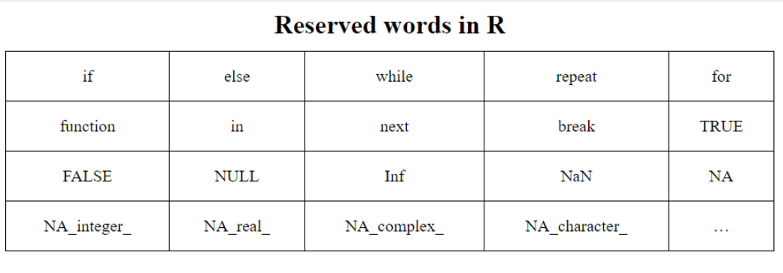
Index starts from 1
Data Types :
Numeric: (e.g., 10.5, 55) Decimal values. This is the default for numbers.
Integer: (e.g., 1L, 45L) Whole numbers. The L suffix tells R to store it as an integer.
Logical: (TRUE, FALSE) Boolean values.
Character: (e.g., "Hello", "24.5") Text strings.
Complex: (e.g., 3 + 2i) Real + imaginary parts.
Add
- c(v, x) → add end
- append(v, x, after = i) → insert at position
Delete
- v[-i] → delete index
- v[v > 10] → delete condition-based
Recycling
- Short vector repeats
- Multiple → safe
- Not multiple → warning

Reading and Getting Data into R
For csv
library(readr)
data <- read_csv("my_data.csv")
For excel : library(readxl)
data <- read_excel("data.xlsx", sheet = 1)

Structure | Dimensions | Homogeneous? | Use Case
Vector | 1 | Yes | Basic list of values
Matrix | 2 | Yes | Mathematical operations
List | 1 | No | Storing complex results/models
Data Frame | 2 | No | Statistical datasets

"Data Wrangling" - the process of transforming raw data into a format suitable for analysis.
Viewing and Inspecting Objects
ls(): Lists all named objects in your current environment.
str(object): Shows the internal structure (types, dimensions, and a preview of data).
summary(object): Provides a statistical summary (Min, Max, Mean, etc.).
head() / tail(): Displays the first or last 6 rows.
View(object): Opens a spreadsheet-style viewer in RStudio.

Manipulating Data Frames (The "Base R" Way)
Before using modern packages, you must understand the core syntax for handling data frames.
Accessing & Extracting
R uses [row, column] indexing.
- By Index: df[1:5, 2] (Rows 1-5, Column 2).
- By Name: df$column_name or df[["column_name"]].
- Logical Filtering: df[df$age > 25, ] (All columns where age > 25).
Combining & Merging
- rbind() / cbind(): Combine by rows or columns (must have matching dimensions).
- Inner Join :
merge(df1, df2, by="ID"): Joins two data frames based on a common key.
Left Join : merge(df1, df2, by = "ID", all.x = TRUE)
Right Join : merge(df1, df2, by = "ID", all.y = TRUE)
Full Outer Join : merge(df1, df2, by = "ID", all = TRUE)
The Tidyverse: Dplyr and Tidyr
The Tidyverse is a collection of packages designed for data science. It introduces the Pipe Operator (%>%), which allows you to chain functions together.
Dplyr (Data Manipulation)
- filter(): Pick rows based on conditions.
- select(): Pick columns by name.
- mutate(): Create new columns derived from existing ones.
- arrange(): Sort data (e.g., arrange(desc(price))).
- summarise(): Collapse many values into a single summary.

dplyr | SQL Equivalent
filter() | WHERE
select() | SELECT
mutate() | New column
arrange() | ORDER BY
summarise() | Aggregate
group_by() | GROUP BY
Tidyr (Reshaping Data)
Most R functions expect "Tidy Data" (one observation per row).
- pivot_longer(): Convert data from "wide" to "long" (e.g., changing column headers like 'Year 2020', 'Year 2021' into a single 'Year' column).
- pivot_wider(): The inverse; turning long data into wide format.

Make data “tidy”
✔ Each column = one variable
✔ Each row = one observation
✔ Each cell = one value

Function | Purpose
pivot_longer() | Wide → Long
pivot_wider() | Long → Wide
separate() | Split column
unite() | Combine columns
drop_na() | Remove NA rows
replace_na() | Replace NA
fill() ->(default=down) | Fill missing values
Control Structures
- if/else → decision
- for/while → repetition
- apply family → functional loops (preferred)
Built-ins
- Numeric → abs, sqrt, round, log
- Character → paste, substr, toupper
- Stats → mean, median, sd, cor
Function | Output (apply() family)
lapply() | List
sapply() | Vector / Matrix
apply() | Matrix operations
Vector Recycling is a unique and powerful behavior that occurs when you perform an operation on two vectors of unequal length. Instead of throwing an error, R "recycles" (repeats) the shorter vector until it matches the length of the longer one

If the longer vector's length is a multiple of the shorter vector's length, the recycling happens silently and cleanly.
The Warning Rule (Fractional Recycling)
If the longer vector is not a multiple of the shorter one, R will still perform the operation, but it will issue a warning. This is because the shorter vector "wraps around" but doesn't finish a full cycle on the last pass.

1. rep(): Replicating Elements
The rep() function is used to replicate values or vectors. It is more flexible than simple recycling because you can control exactly how the repetition occurs.
- times: Repeats the whole vector $n$ times.
- each: Repeats every individual element n times before moving to the next.
x <- c(1, 2)
rep(x, times = 3) # Result: 1, 2, 1, 2, 1, 2
rep(x, each = 3) # Result: 1, 1, 1, 2, 2, 2

seq(): Sequence Generation
While the colon operator (1:10) creates sequences of integers, seq() allows for complex increments and specific lengths.
- by: Defines the increment (e.g., counting by 0.5).
- length.out: Tells R how many numbers you want; it calculates the spacing automatically

which(): Finding Indices
The which() function converts a logical vector (TRUE/FALSE) into a numeric vector of indices. This is crucial when you need to know where a condition is met, rather than just if it is met.
duplicated(): Identifying Repeats
This function is a primary tool for data cleaning. It returns a logical vector indicating which elements are duplicates of an earlier element.
- The first occurrence is marked FALSE.
- Every subsequent occurrence of that same value is marked TRUE.

is.na(): Handling Missing Values
In R, missing data is represented as NA (Not Available). Most mathematical functions (like sum or mean) will return NA if even one value is missing. is.na() is used to detect these gaps.
In Queuing Theory, what does the 'M/M/1' model signify regarding the arrival and service processes?
Markovian arrivals, Markovian service times, and 1 server.
Right answer
In Kendall's notation, 'M' stands for Markovian (or Poisson/Exponential), and the '1' represents the number of servers.
When exporting data to a CSV file in R, which argument in write.csv() should be set to FALSE to prevent R from adding an extra column of row numbers to the file?
By default, write.csv includes row names; setting row.names = FALSE ensures only the data columns are exported.
You have a list L <- list(a = 1:5, b = "hello"). Which command specifically extracts the numeric vector 1:5 such that the result is a vector, not a list of length 1?
L[[1]]
In an M/M/1 queuing model, if the arrival rate lambda is 8 per hour and the service rate myu is 10 per hour, what is the 'Traffic Intensity' (utilization) of the system?
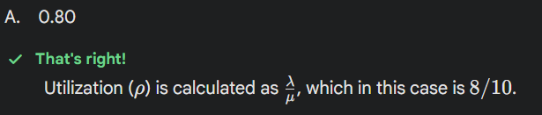

What happens when you attempt to create a vector using x <- c(1, "2", TRUE)?
All elements are coerced into the character type.
Right answer
When types are mixed in a vector, R coerces them to the 'least restrictive' type, which is character.
What happens when you attempt to create a vector using x <- c(1, "2", TRUE)?
logical → integer → double → character
Your vector contains:
- 1 → numeric
- "2" → character
- TRUE → logical
- Because character is the highest type present,
everything is converted to character. (Type Coercion)
When using left_join(df1, df2) from dplyr, if a key exists in df1 but not in df2, what will appear in the columns originating from df2 for that row?
NA
Right answer : A left_join keeps all rows from the first table and fills in missing matches from the second table with NA.
In ggplot2 (part of Tidyverse), what is the purpose of a 'facet'?
Faceting (like facet_wrap) splits the data into panels to allow for easy comparison across groups.
If you want to sort a data frame df first by 'City' (alphabetically) and then by 'Salary' (highest to lowest), which dplyr code is correct?
df %>% arrange(City, desc(Salary))
Right answer
The arrange function sorts in ascending order by default, and the desc() helper reverses it for Salary.
Vectorization allows R to apply the operation to the entire vector at once using optimized C/Fortran code.

It concatenates strings without any separator between them by default.
paste0(...) is a shortcut for paste(..., sep = ''), which is useful for creating file paths or IDs.
What does the recode() function in dplyr allow you to do?
Recode is excellent for replacing old category names (e.g., 'M' to 'Male') with new ones.
When using read.table(), what does the stringsAsFactors = FALSE argument ensure? (Note: This was the default in older R versions)
That text columns are kept as 'character' type instead of being converted to 'factors'.This prevents R from automatically creating categories out of every text column, which often makes data cleaning difficult.
search(): The search() function displays the 'search path', which includes all attached packages and environments.
📌 What is a Factor?
A factor is a data structure in R used to represent categorical data.
What is ggplot2?
ggplot2 is a data visualization package based on the idea:
A plot = data + mappings + geometric objects.Instead of “draw this chart”, you describe how data maps to visuals.
Think in layers:
- Data → what you plot
- aes() → how variables map to axes / color / size
- geom_* → how it looks (points, bars, lines, etc.)
Line Plot — geom_line(), Bar Chart — geom_bar() ->counts vs geom_col()-> actual values
Histogram — geom_histogram()
Boxplot — geom_boxplot()
Scatterplot - geom_point()
Aesthetic | Meaning
x, y | Axes
color | Border / points
fill | Inside color
size | Point size
shape | Point shape
Facets (Multiple Plots)
ggplot(df, aes(x = price, y = quantity)) +
geom_point() +
facet_wrap(~ product)
✔ One plot per category

Python Programming
Which dictionary method would you use to retrieve a value safely without raising a KeyError if the key does not exist?
The get() method returns the value for a key if it exists, otherwise it returns None (or a specified default).
Which Seaborn function is commonly used to visualize the distribution of a single numerical variable by showing a histogram combined with a kernel density estimate (KDE)?
The displot() function is the modern Seaborn interface for plotting univariate or bivariate distributions of data.

Python
Aspect | Shallow Copy | Deep Copy
Outer object | New | New
Inner objects | Shared | Copied
Memory usage | Low | Higher
Speed | Faster | Slower
Risk of side effects | High | None
Shallow copy banne pr copy as well as original both will be changed
Deep copy’s change are limited to just copy and not original
Method | Type
= | ❌ No copy (just reference)
copy.copy() | Shallow
copy.deepcopy() | Deep
list[:] | Shallow
dict.copy() | Shallow

Duplication: “Multiple copies, no relationship.”
Replication: “Multiple copies, actively synchronized.” (Database Replication)
Python and Java are NOT call by reference
They are call by value of reference
Call by value no change in original value’
An iterator is an object that lets you traverse elements one at a time.
_iter__() → returns the iterator itself
_next__() → returns next value, raises StopIteration when done
🔹 What is a generator?
A generator is a simpler way to create iterators using yield.
Generator = iterator + less code + lazy execution Why yield is special
- Pauses function execution
- Remembers state
- Resumes from last yield
- Every generator is an iterator, but not every iterator is a generator

🔹 What is a decorator?
A decorator modifies the behavior of a function without changing its code.
For Logging :
The standard hierarchy is DEBUG < INFO < WARNING < ERROR < CRITICAL.
How does 'Data Hiding' (encapsulation) typically manifest in Python class attributes?
Using a double underscore prefix (e.g.,__attr) to trigger name mangling.Name mangling changes the internal name of the attribute to make it harder to access from outside the class, simulating private variables.

